Fellowship Church
407 Perry Ave.
Big Rapids, MI

www.fellowshipcrc.net
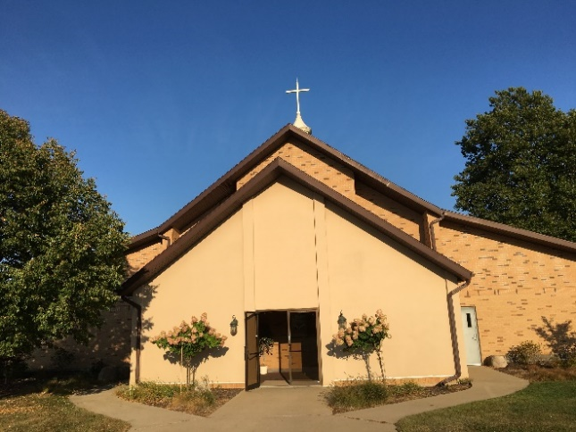
231-796-3517

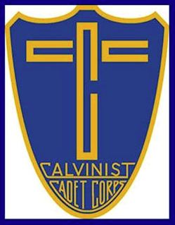
CADET MINISTRY
God is Revealed in His Word
The Cadet ministry encourages studying the Bible as the guide to life.

God is Revealed in Nature
The Cadet ministry encourages experiencing the presence of the Lord in His glorious creation. Learning the skills of an outdoorsman builds a boy’s character, and developing a boy’s understanding of his place in God’s world helps him to be a faithful steward.

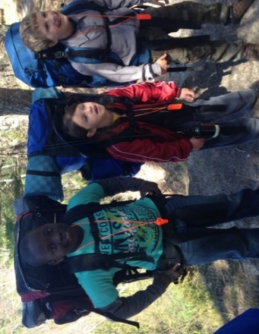
Men as God’s Servants
The Cadet ministry is men of God who are dedicated to bring boys into a living relationship with their Lord and Savior. These men, understanding their imperfection, hold on to the promise that the Lord will bless their prayers, their example, and their instruction if they rely on God’s strength.

This Year’s Theme Verse
For this is what the Sovereign Lord says: I myself will search for my sheep and look after them.
- Ezekiel 34:11

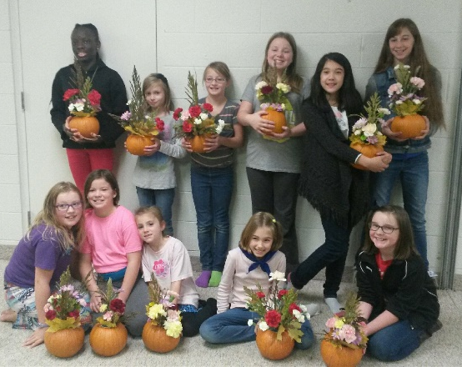

Mission
The mission of GEMS Girls’ Clubs is to help bring girls into a living, dynamic relationship with Jesus Christ.

Vision
Our vision is to see girls around the world actively and enthusiastically expressing love for God and others—girls equipped, motivated, and passionately engaged in living out their faith.
Together, our goal for every club meeting is to grow bigger hearts. Together, we will learn how to love and care for one another, other people, ourselves and our relationship with God. And we’ll do this by learning about Jesus Christ, what He has done for us, and His plans for each of our lives.

Whoever claims to live in him must live as Jesus did (1 John 2:6).

Kingdom Kids

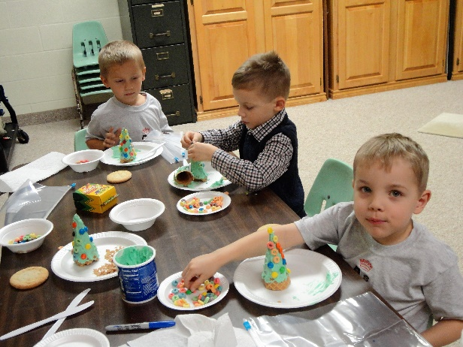
A coed curriculum for four- and five-year-olds! This curriculum will help lay the foundational blocks of faith into the life of a child. Each lesson is designed to help children know God better and understand that when we know Him, we want to act and behave in ways that please Him. Using a learning center approach, children will travel around to different centers to examine the character qualities of Jesus and discover that they want these same qualities in their own life — “I want to be like Jesus.”

Youth Group
At Fellowship Church we have a goal to bring young people together in a life of faith, action and fellowship, and address spiritual, emotional, and social needs unique to youth. We want to create a safe and nurturing space for teenagers to gather together and share their joys and concerns with each other and with caring adults.
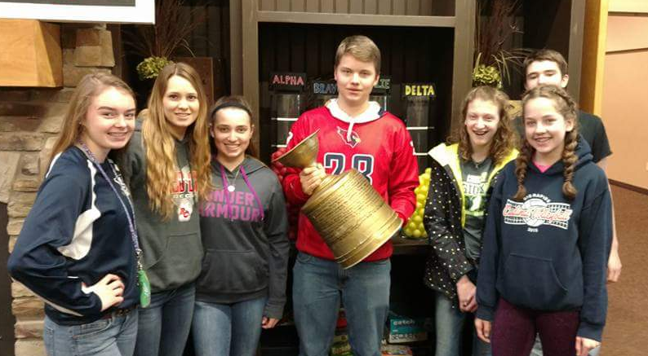

Adult Bible Study
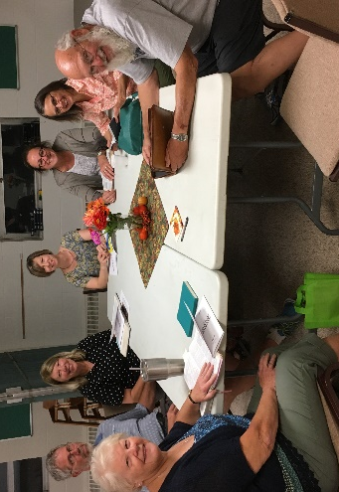
During this adult study Pastor Ken will be going in depth as he discusses the specific biblical sights he visited in Israel during his sabbatical. We’ll look at the importance of geography, archeology, culture, and language with an eye toward understanding our Bibles better. And as we study specific sights we’ll look closely at biblical passages with the hope of drawing nearer to our Lord by studying his life and ministry.

Schedule & Menu

The evening begins with a meal served from 5-5:30 pm.
Donation $2/adult; $1/child

Sept. 24 – Pizza
PB&J available at every mealal.

Oct. 8 – Sandwiches
Oct. 22 – Burrito Wrap
Nov. 5 – Hotdogs
Nov. 19 – Pizza
Dec. 3 – Sandwiches
Dec. 17 – Burrito Wrap
Jan. 14 – Hotdogs
Jan. 28 – Pizza
Feb. 11 – Sandwiches
Feb. 25 – Burrito Wrap
Mar. 11 – Hotdogs
March 25 – Pizza
Apr. 8 – Sandwiches
Apr. 22 – Burrito Wrap
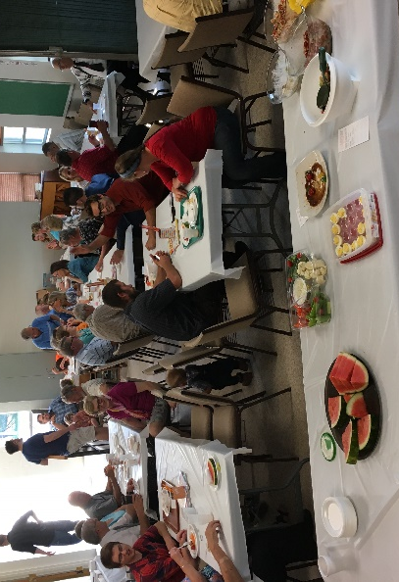
May 6 - Hotdogs

